Lab 01: Configuring Palo Alto NGFW
(Total points: 15)

Task 1: Identifying the Network Configuration (5 Points)
Question 1. Identify the IP addresses of the following elements and submit the screenshot of the IP addresses (from the terminal/command prompt/Palo Alto CLI)
Answer:
- The IP Address of the host machine:
- The IP address is: 10.0.0.4

- The IP Address of the Management Interface:
- The IP Address is: 192. 168. 56. 101

- The IP Address of the PA-VM interface connected to your internal network:
- The IP Address is: 10. 0. 2. 20/24

- The IP Address of the PA-VM interface connected to the external network:
The IP Address is: 192. 168. 57. 30/24

- The IP address of the Windows 10 machine
- The IP Address is: 10. 0. 2. 4

Task 2: Configuring the Palo Alto Device Options (3 Points)
Question 1. Complete the configuration of the Device options. Log out of the management interface and submit the screenshot of the Login Banner- Welcome Cyber Defenders!
Answer:
Screenshot-
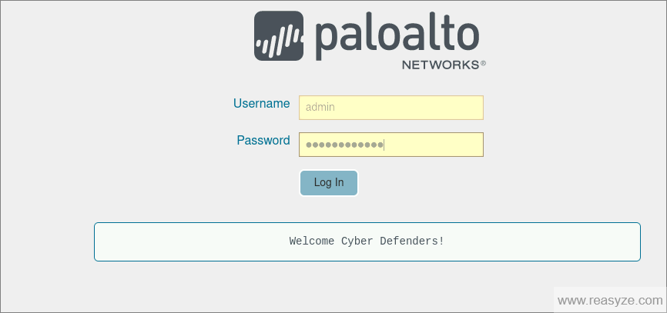

Task 3: Creating a basic firewall security policy (4 Points)
Question 1. Complete the configuration of the basic firewall policy. Submit the screenshot of the summary of the basic firewall policy (in the Policies > Security section) and submit the screenshot of the command tracert 8.8.8.8 (from the Windows 10 VM command prompt) which depicts that the connection is routed via the firewall.
Answer:
Screenshot 1 - Summary of the basic firewall policy
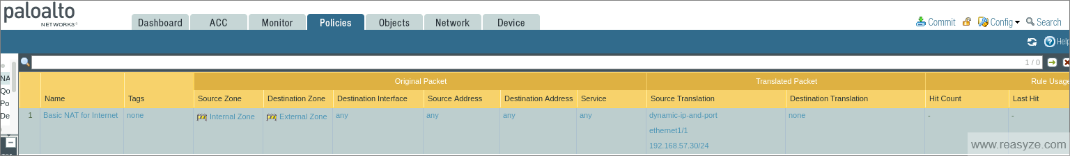
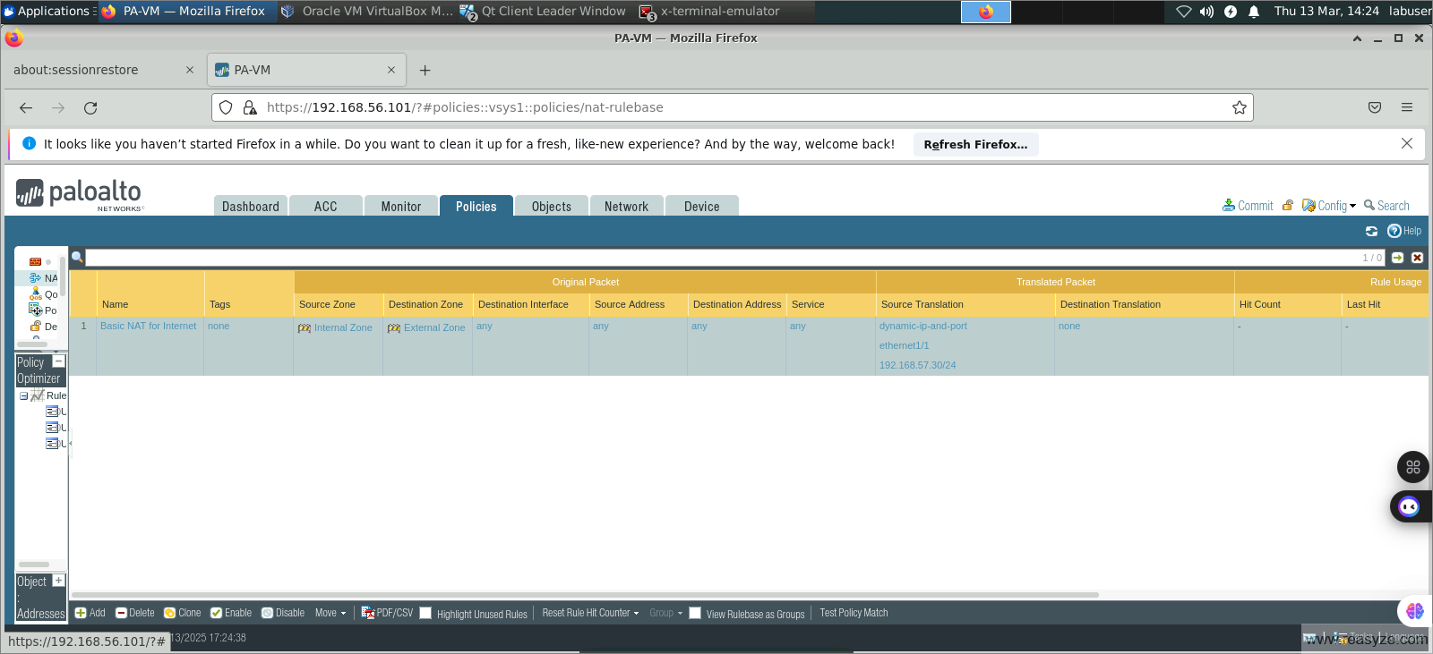
Screenshot 2 – Command output (of tracert 8.8.8.8) from command prompt of Windows 10 VM
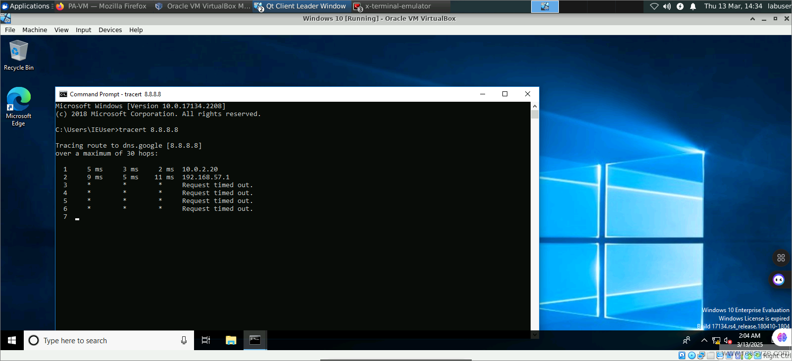

Task 4: Block websites based on provided rules (3 Points)
Question 1. Complete the configuration as required and submit screenshots of the ping scans from the Windows 10 VM (for Facebook) and the website links provided below.
Answer:
Screenshot 1- Blocked (Request Timed out) ping scan of Facebook

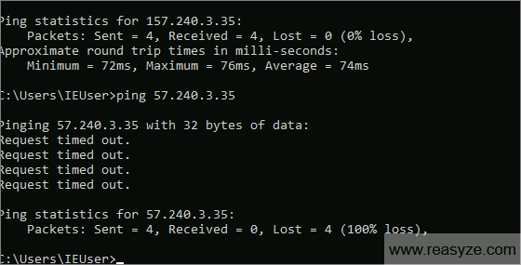
Screenshot 2- Blocked (webpage) of websites- https://www.cnnic.com.cn/ and https://www.sina.cn/ from Microsoft Edge.
